Guidelines for Viewing after Yeondo

1. Yeondo (Prayer Service) Seating for the Family
- Before the Yeondo begins, family members should take their seats at the two reserved chairs at the front left side of the church.
- If additional seating is needed, please inform a volunteer.

2. Viewing (Farewell to the Deceased)
- After Yeondo, there will be a moment to bid farewell to the deceased.
- When a volunteer signals, family members should stand to the left of the altar as shown in the provided diagram.
- The priest, sisters, and mourners will come forward to pay their respects to the deceased and greet the family.
- Once the Viewing concludes, the family will have a final moment with the deceased before the casket is closed.
- As the casket exits the church, the portrait bearer should also exit carrying the portrait.
- After exiting, family members should stand behind the cross bearer to prepare for the entrance procession.
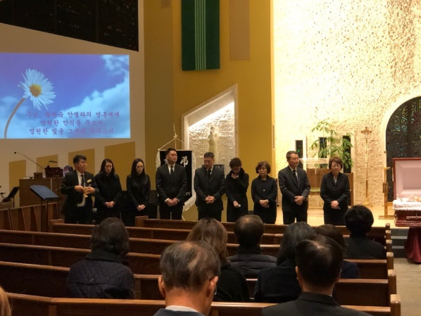

3. Entrance Procession
- Pallbearers should arrive 30 minutes before the ceremony to receive a boutonniere, white gloves, and position assignments with the help of volunteers.
- Family members should line up behind the cross bearer as indicated in the diagram.
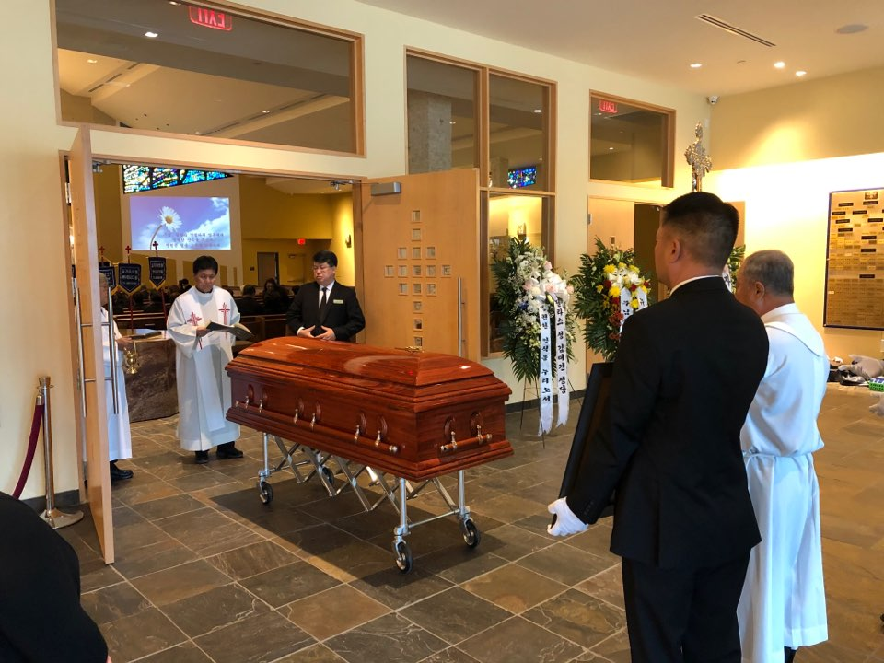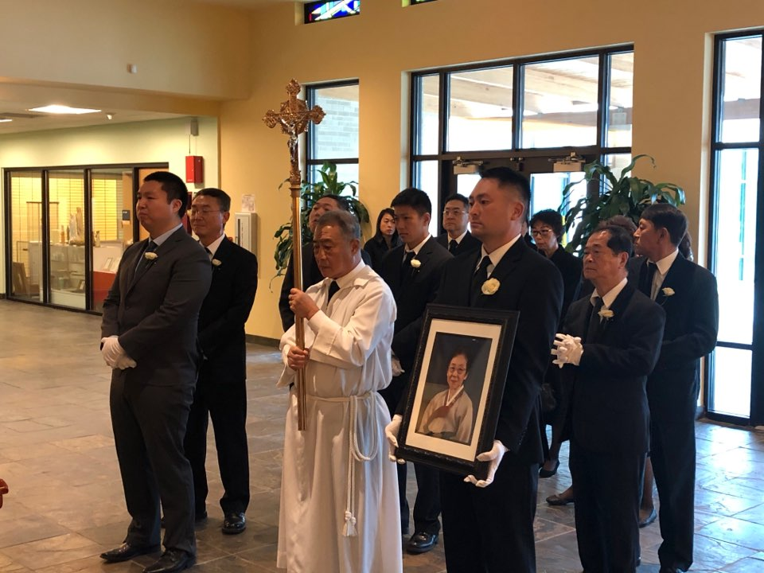
- Upon entering the church, pallbearers should be seated at the front right, while family members take their seats on the left.
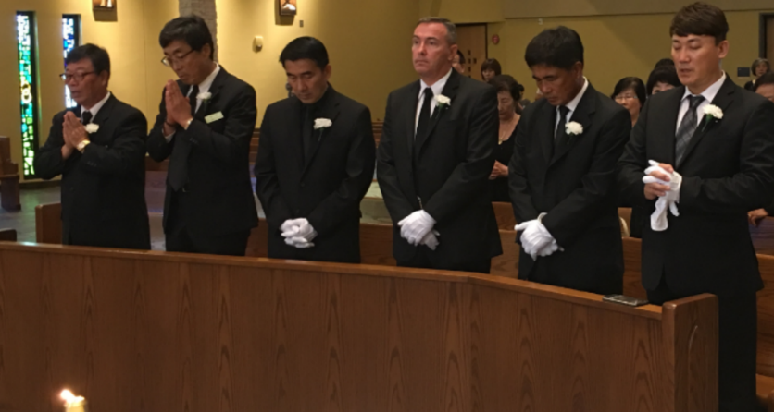
- After the ceremony, a volunteer will remove the altar candles and rotate the casket for the recessional.
- Participants should then return to their positions and prepare for the exit procession.

4. Farewell Ceremony
- Choose up to six participants for the Farewell Ceremony and inform a volunteer.
- Discuss and decide where each participant will stand with the family.
- Participants should stand on either side of the casket, leaving a space of approximately two tiles between each person.
